|  |  |
| --- | --- |
| **Sony ZV-1 Camera**  Máy ảnh Sony ZV-1 (Black) | Chính hãng  Sony ZV-1 01 Sony ZV-1 02 Sony ZV-1 03 Sony ZV-1 04 | **Featured information**   * Sensor: BSI CMOS 1 inch * ISO range: 100 to 12800 (Extended: 64 to 25600) * Resolution: 20MP * Wireless connection: WiFi, bluetooth   Price: 800$  **Specifications:**   * **Sensor Format:** No * **Resolution:** 20.1 megapixels * **Size photo:** 5472 x 3648 * **Image Proportions:** 1:1, 3:2, 4:3, 16:9 * **Sensor Type:** CMOS * **Image Format:** JPEG, Raw * **Anti-Vibration:** Digital, Optical * **Lens Mount:** No |

**Description:**

#### **Sony ZV-1 camera**

Featuring a 3.0' flip-out touchscreen and 3-way directional microphone perfect for front-facing recording, the Sony ZV-1 also has features that make Vlogging easier like Product Introduction Settings , Background Blur, Soft Skin Effect and Face Priority auto-exposure functions.

#### **Design of Sony ZV-1**

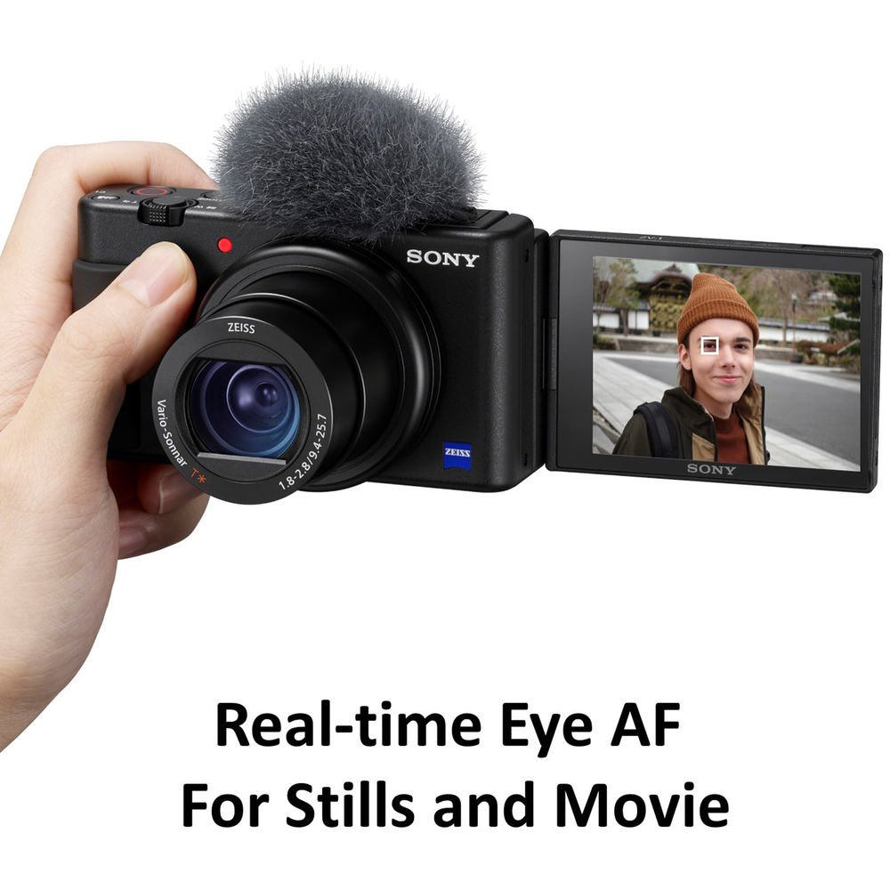

Despite its sleek and lightweight design, the Sony ZV-1 is still equipped with a large grip on the right side for easy one-handed recording combined with a front notification light, a larger REC button on the top of the camera, and a hotshoe for attach accessories.

